**About The Bug:**

After selected the Bengali language whole page of [Bangladesh's Largest Online Ticket Destination | Shohoz](http://shohoz.com/) change into English to Bengali except phone number of shohoz help line.

Heres the Bug Screenshot of shohoz.com with yellow color makr.

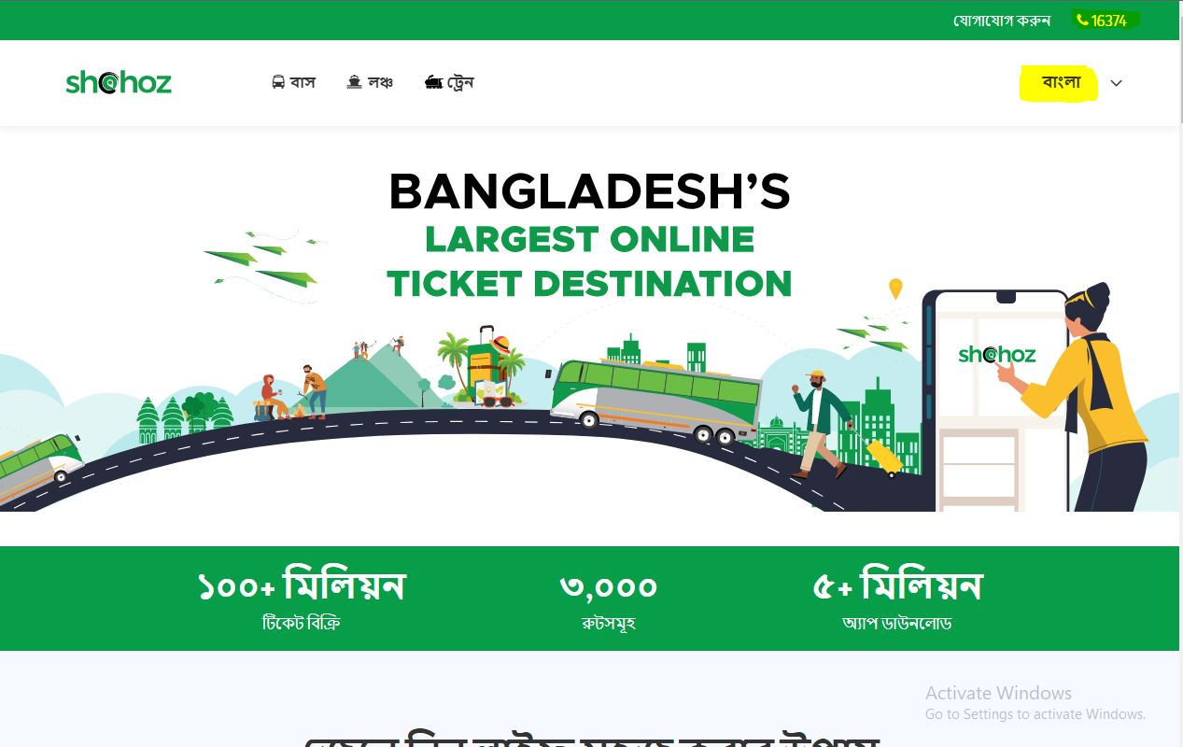

Adding the bug on Jira management Tool. It is called To Do Phase.

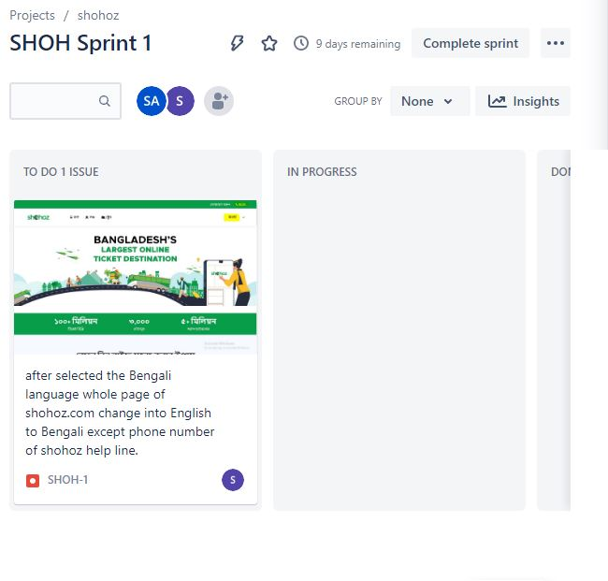

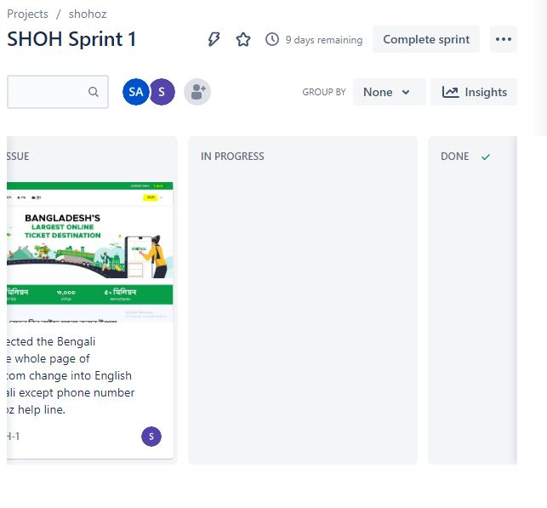

Developer see the issue.

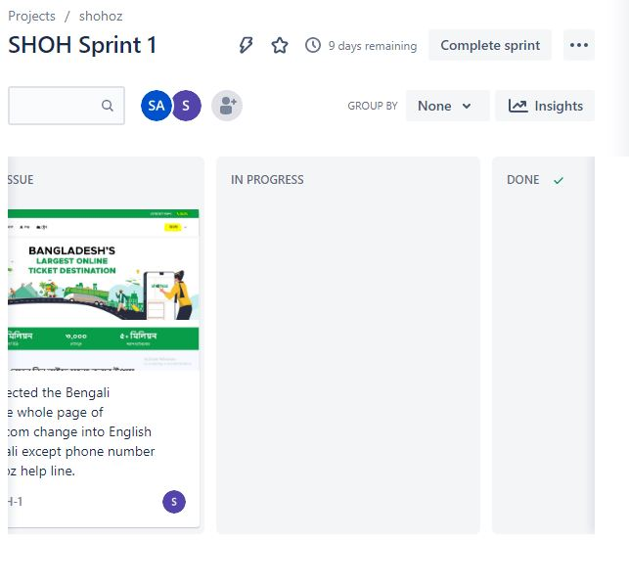

After Adding this bug to the developer, The developer Receive the bug and it is in progress and the developer start to work on it.

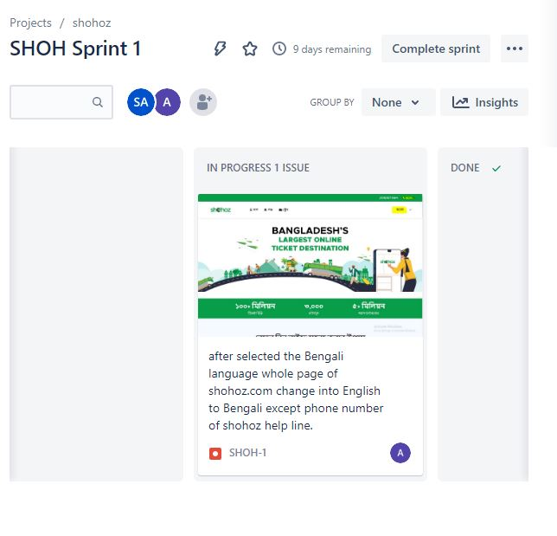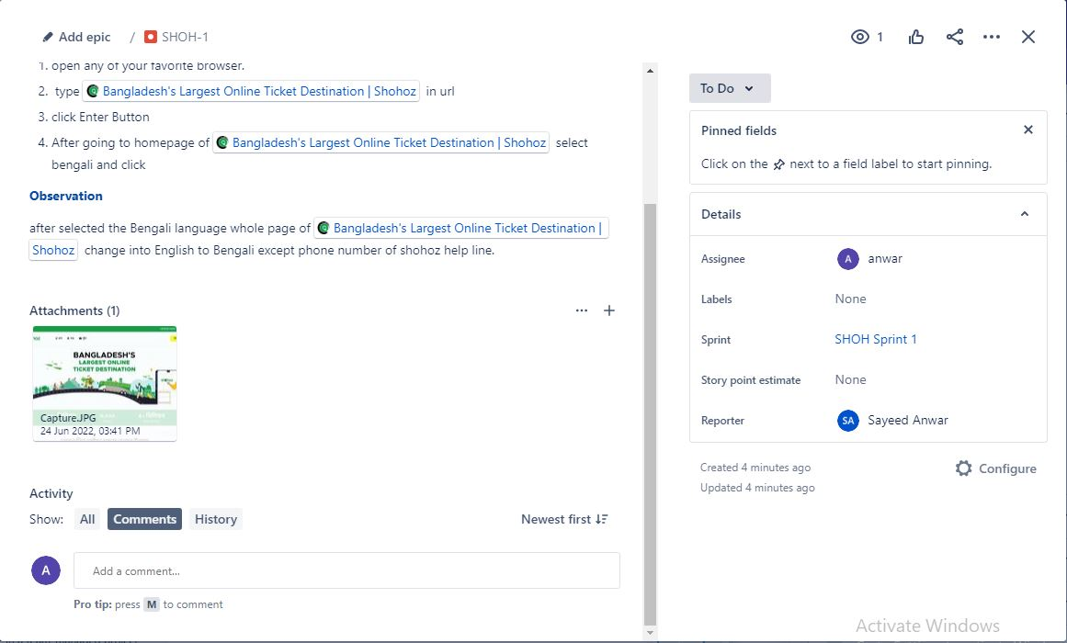

After Fixed the bug The developer add a note and make it as Done.

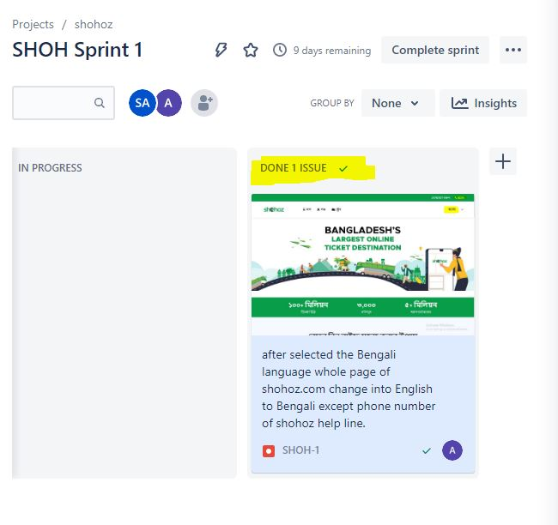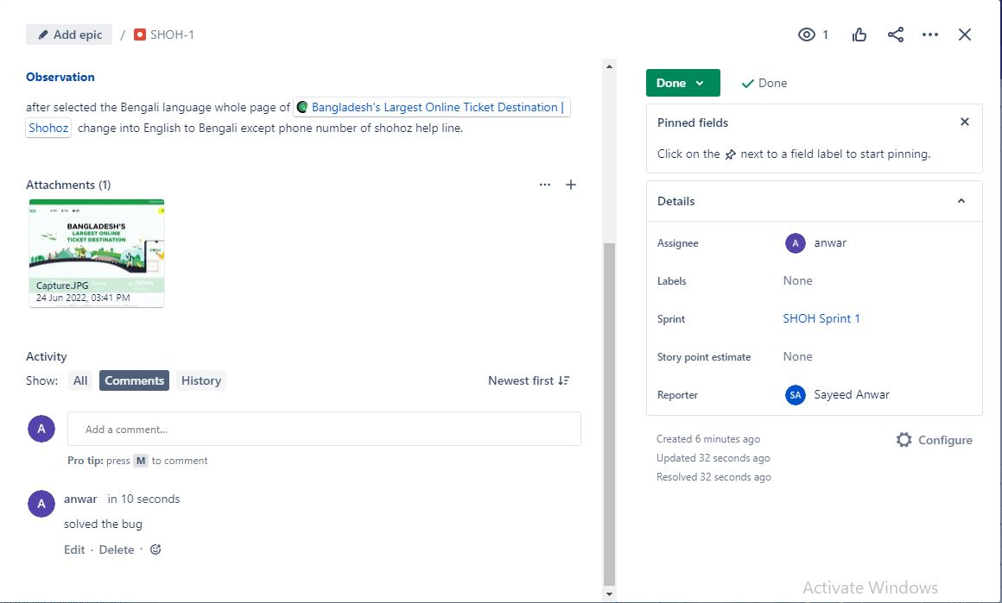

And finally fixed the Bug.